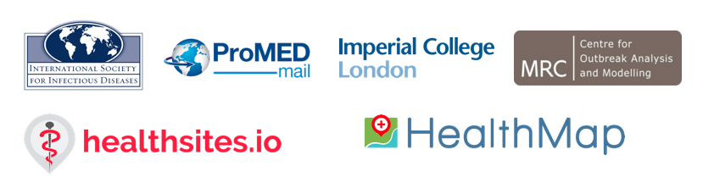

**Mapping the Risk of International Infectious Disease Spread (mriids)**

A project funded through USAID’s “Combating Zika and Future Threats: A Grand Challenge for Development” program

*Milestone 5*

*November 1, 2017*

Milestone Description

1. Consultations with end users to update guidance on priorities (pathogen and associated disease, geographical region, and the factors of spread) completed.
2. Data on healthcare facilities and additional factors influencing the spread of disease as agreed during end user consultations collected and curated.
3. Open-source platform to host the database and make it publicly accessible designed, developed, and deployed.

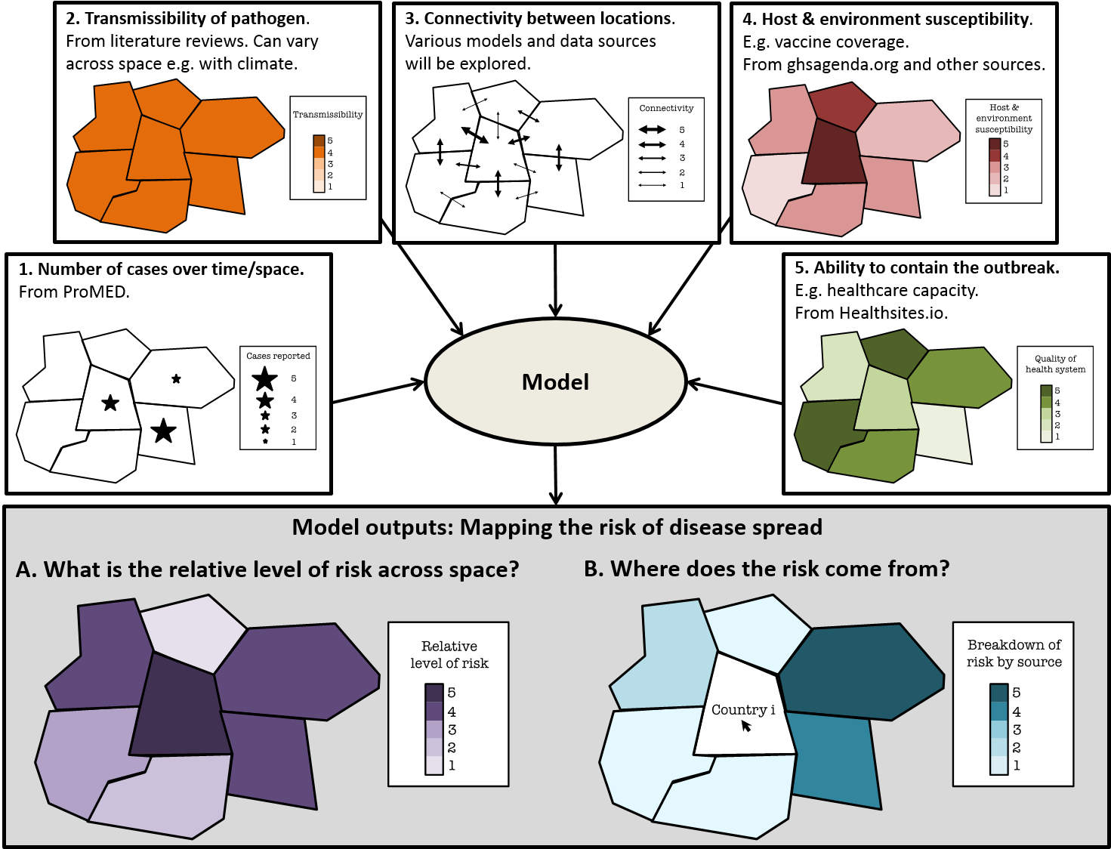

Figure 1. Schematic of the Project

1. **Consultations with End Users**

For this portion of the project, we were fortunate to work with the Dalberg Design Impact Group (DIG) who conducted in-depth research to refine the project vision, develop the end user personas and provide insights on technical requirements of the platform. Figure 2 summarizes the activities and participants in the end user research that was carried out. The research included remote interviews and in-country concept testing in Sierra Leone and Senegal. The results were presented to the mriids team by the Dalberg DIG team including specifications around a product vision based on the end user feedback.

Motivations, attitudes and operating environment was assessed for different end-user groups and further defined health managers as the primary end-users followed by technical experts and media & communication experts as secondary end-users.

A key finding was that a knowledge gap existed between the scientific community and public health policy makers, causing a disconnect between the anticipation of global public health threats and the planning of preventions to combat them. mriids is positioned to fill the gap between technical experts and public health managers by providing a map-based interface and intelligent algorithm that leverages publicly available data to report new cases of infectious diseases and provide short-term predictions of disease spread across a region. mriids serves as an international, early warning system that helps mitigate the catastrophic effects of outbreaks by strengthening capacity, supporting resource allocation decisions and informing public health planning.

Specific strategic recommendations included:

* Addressing gaps in prediction capabilities by including additional data sources and partnerships to overcome skepticism and increase the utility and credibility of the platform
* Better visualize publicly available data to help encourage routine use and adoption of the mriids platform at the country level
* Use innovative data to provide a unique view into public health and better identify trends and risks to provide added context and strengthen the unique value of the mriids platform

Two different sets of activities were recommended in the short term in order to realize the strategic vision for mriids:

1. Build a proof of concept demo to visualize the mriids product experience while also establishing the algorithm’s prediction capability. This will serve to attract future funding and will appeal to potential technical partners like CDC and WHO. It also builds on the original plan to release a public portal in the Fall.
2. Focus on better visualizing public health data, for example from WHO, to build the digital habits of West African Health Managers, who would then be better prepared to understand and interact with a prediction tool in the future; selecting one country for early pilot lays the foundation for a strong feedback loop for the tool’s future development.

The mriids platform should be accessible to any health manager with internet access, but specifically designed for the needs and habits of users in countries with weak health systems and poor technology access. Key differentiating features include:

While the technology and algorithm are under development this product vision illustrates the basic feature set that might be effective for an mriids “minimum viable product,” which are summarized here.

Accessibility:

The mriids product helps those with access to the website, as well as those who need this information, and don’t have easy access to the website. This is accomplished by making it:

Responsive (e.g. not a smartphone app)

Low bandwidth/loads quickly

Multi-lingual

Ability to integrate with texting

Part of an ecosystem that supports the sharing of this information through other channels (WhatsApp, SMS, printed materials)

Interoperability

Ability to publish directly to the regional news section from the Emergency Operation Center’s (EOC’s) media team.

Data

Historical case data at international, national and district levels, disaggregated by month, with options to download/share.

Outbreak Resources

Quick disease facts are very useful as the disease/medical training of users may be weak, especially in cases where an uncommon disease occurs.

Visualizations

Disease information easily available for analysis and sharing with others.

Relevant and Shareable Analysis

Technical experts often publish in medical or academic journals, whose content is static and delayed by the publishing process. Scientific jargon is hard to understand for non-experts and translating this information into clear action points is difficult. The map-based interface of mriids reflects spatial distribution of reported cases, which makes analysis easier and more relevant, and provides easy to understand prediction visualization tools.

Encourages Coordination and Collaboration

Because public health threats aren’t restricted to national borders, they can become larger problems that require international knowledge sharing and coordination, which causes delays in response efforts. mriids includes a country directory and discussion boards that support cross-border communication, coordination and collaboration.

Reputable and Timely Sources

In countries without strong health systems, disease surveillance data is often inadequate, and it is in these countries where infectious diseases have the highest likelihood of becoming global pandemics. mriids works off reported case data culled from reputable sources of publicly available data, such as ProMED reports, and are therefore available in a timely manner.

Trusted and Actionable

mriids speaks in plain language but provides tools for rigorous analysis (e.g. downloading .CSV files, sharing map imagery and case reports) to provide a trusted, yet easy to understand, experience.

Day-to-day Disease Monitoring

Predicting the risk of disease spread requires broad data sets from a multitude of sources. Alert tools congregate data sources to make day-to-day disease monitoring less burdensome within existing workflows.

While we originally planned to consult with end users to update guidance on priorities (pathogen and associated disease, geographical region, and the factors of spread), we found that our initial consultations with the advisory board in November 2016 and subsequent interactions were sufficient to decide on these priorities. Instead, we focused our end user consultations on how to make an effective final product and the features required for a minimum viable product.

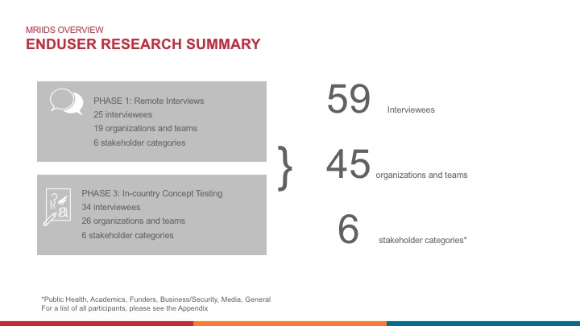

Figure 2. End User Research Summary

1. **Data on Healthcare Facilities**

Healthsites publishes health facility data under an open data license (ODbL) and requests organisations and Ministries of Health to share data under this license.

To date we have loaded Ministry of Health data for Sierra Leone, Tanzania, Ghana and Rwanda.

MSF have shared 777 health facilities which have been loaded to the East Congo region of Healthsites.

Other organisations such as eHealth Africa and American Red Cross have been able to save their data directly to OpenStreetMap. These facilities have been added to Healthsites to import 34239 facilities from OSM.

Recently we have had contact with The Gates Foundation who have offered to support our Senegalese Freedom of Information request and discuss how best to establish data collaborative in support of this work.

https://healthsites.io/

https://data.humdata.org/organization/healthsites

**OpenStreetMap**

**Data loaded from OpenStreetMap**

Details:

Uploader: OSM

Uploaded on: 2017-04-04 11:23:37.677767+00:00

Finished loading on: 2017-04-04 14:03:59.464507

Number of created locality: 34239

**Senegal**

|  |  |  |  |  |  |  |
| --- | --- | --- | --- | --- | --- | --- |
| Senegal | Number of Healthsites | Basic | Partial | Complete | Laboratory | Hospital |
|  | 282 | 43.6 | 56.4 | 0% | - | 206 |

[Data](https://docs.google.com/spreadsheets/d/1JvAOsixerZczs229p1iVMklmlIrDAl_xN6JXAgF-UoE/edit?usp=sharing)

In Senegal in addition to requesting health facility data from the Ministry we have made requests to PATH and Intrahealth. Both of these organisations have accurate and up to date data and are working closely with the Ministry of Health. However, they need authorisation from the Ministry to share.

WHO Senegal have 304 locations that we are waiting to load.

https://data.humdata.org/dataset/senegal-healthsites

**Sierra Leone**

|  |  |  |  |  |  |  |
| --- | --- | --- | --- | --- | --- | --- |
| Sierra Leone | Number of Healthsites | Basic | Partial | Complete | Laboratory | Hospital |
|  | 1862 | 0.4 | 99.6 | 0% | 5 | 206 |

[Data](https://docs.google.com/spreadsheets/d/1hb3InCyndwk4fbf5dagdNSHkAyDfIhOLV4dLl1ZjVxI/edit?usp=sharing)

The data that has been collected on Healthsites for Sierra Leone comes from a variety of sources. Much of this data was gathered and shared during the Ebola response.

Currently the link to the original data shared is down. http://health.gov.sl/

A request for the updated list has been made to the Ministry of Health through USAID Sierra Leone.

**Uganda**

[Data](https://docs.google.com/spreadsheets/d/1HiC19YBhWTsi96rXQ2nOd5nHlafC3UFhEjS6VFgP28A/edit?usp=sharing)

In addition to the FOI request we are working with our project partners The Humanitarian OpenStreetmap Team to access and improve health facility data in Uganda.

Freedom of Information request sent

http://askyourgov.ug/request/health_care_location_details_for

**Nigeria**

The Gates Foundation along with eHealth Africa are publishing health facility data for this region and have recently shared a list of Health facilities. We are in the process of preparing this data for release.

[**Data**](https://docs.google.com/spreadsheets/d/1ZLn9AS5FWKNtTFBzqYnCTlaMdnSY4fjg0h0UFQ__wGM/edit?usp=sharing)

**Central African Republic**

The IFRC, in conjunction with the CAR ministry of health, in 8 districts of CAR in conflict areas, which are largely unmapped. They plan to map all health facilities in these areas, starting with getting GPS points for health facilities in Kemo. *In Kemo we have 37 health facilities already mapped, and over the course of the next year—depending on when areas are accessible—we will be aiming to get all 111 of the following as well (****centre pev = offers immunisation services****):*

| centre_pev

district | non oui | Total

----------------+---------------------------------+----------

ALINDAO-MINGALA | 0 16 9 | 25

|

----------------+---------------------------------+----------

BAMBARI | 0 8 26 | 34

|

----------------+---------------------------------+----------

BANGASSOU | 4 10 17 | 31

|

----------------+---------------------------------+----------

MOBAYE-ZANGBA | 0 14 7 | 21

|

----------------+---------------------------------+----------

Total | 4 48 59 | 111

|

**Liberia**

Freedom of Information request sent

http://infolib.org.lr/request/health_care_location_details_for#outgoing-114

**Ghana**

3757 health facilities have been loaded from http://data.gov.gh/dataset/health-facilities

We are requesting up updated list from the Ministry and have been told this list is out of date.

[**Data**](https://docs.google.com/spreadsheets/d/110Usc-fl1IdjnKCgY4Fp-faUWywmh2O9WuRkkAnsID4/edit?usp=sharing)

https://staging.healthsites.io/map?country=Ghana

**Additional healthcare capacity data: IHME and World Bank data**

We are also exploring other sources to get data on the healthcare capacities of different countries. Some of the more data sources investigated are summarized here.

**World Bank Capacity and Governance Indicators**

Some of the governance indicators could be used as proxy for healthcare quality e.g., number of hospital beds per 1000 people or the number of physicians per 1000 people. These data are expected to updated annually. However, the available information is far from complete. Out of the 264 countries for which data are recorded, the most complete record is for the year 1990 when data for 187 countries are available. For 2012, only 70 countries have complete records. In particular for West Africa, we have non-null records for all countries for 1960 and for 5 of the 6 for 1975. Similarly the number of physicians per 1000 people is also expected to be updated on an annual basis. Once again, this information is available for only 71 countries in 2014 and only 10 in 2015. For West Africa, the data are more complete and the number of physicians per 1000 people is recorded for all six countries in 2010.

**Institute of Health Metrics and Evaluation**

In addition to hospital and/or physicians density in a country, another proxy that could be used to assess the levels of health-care access and quality is the mortality rate from causes that should not be fatal in the presence of effective medical care (i.e., amenable mortality). Researchers have used cause of death and risk factor estimates generated through the Global Burden of Diseases, Injuries, and Risk Factors Study (GBD) to quantify personal health-care access and quality as a single score - the Healthcare Access and Quality (HAQ) Index. This index ranges from 0 (lowest) to 100 (highest) and has been assessed for 195 countries and territories from 1990 to 2015. In particular the index is available for all the countries of interest in West Africa. It is not clear however if this index will be updated on a regular basis.

1. **Open Source Platform**

**MARK/EMILY – please fill out this section**

While the final product website and minimum viable product are being developed, we wanted to be sure to make the data open source and available to the public. We strongly believe that data and methodology transparency is critical for trust and buy-in from stakeholders and the public. We have been using our mriids project GitHub Wiki page (<https://github.com/healthsites/mRIIDS/wiki)> as a resource for demonstrating the project objectives, team, and status. While we develop the final websites, the we have made the HealthMap and ProMED Ebola data available on the GitHub Wiki page. These datacuts are for the entirety of the 2014-2015 West African Ebola outbreak and are what the models are based off of.

Work has begun on the conceptualization and implementation of the minimum viable product page. This will be hosted as a sub-page on the HealthMap website (www.healthmap.org) and will feature a map zoomed in on West Africa with real-time alerts on the map from WHO, AFRO WHO, ProMED and HealthMap data. This data will also be made available for download in csv format. This was identified as an immediate need for public health practitioners in the region – updated data that could be analyzed regularly.